Digital E Gram Panchayat Application

Summary of the project

* Developed a full-stack E-Gram Panchayat web application to enhance the efficiency of citizen service delivery by digitizing gram panchayat service applications
* Designed and extended three system modules (for users, staff, and officers) each with tailored functionalities to streamline service management.
* Achieved a 90% reduction in paperwork by transitioning to a digital platform for service applications and tracking
* Enabled users to submit applications and track their progress online, improving transparency and accessibility.
* Empowered admin and staff to efficiently manage user applications and perform CRUD operations on available schemes.
* It is build using HTML , CSS , JS for frontend.
* For backend I used Node.js , Express.js , EJS template for dynamic pages.
* For database I have used postgres database which is a relational database.

Details of webpages of the project:-

1. At first when we open the website we are navigated to the home page which looks like :-

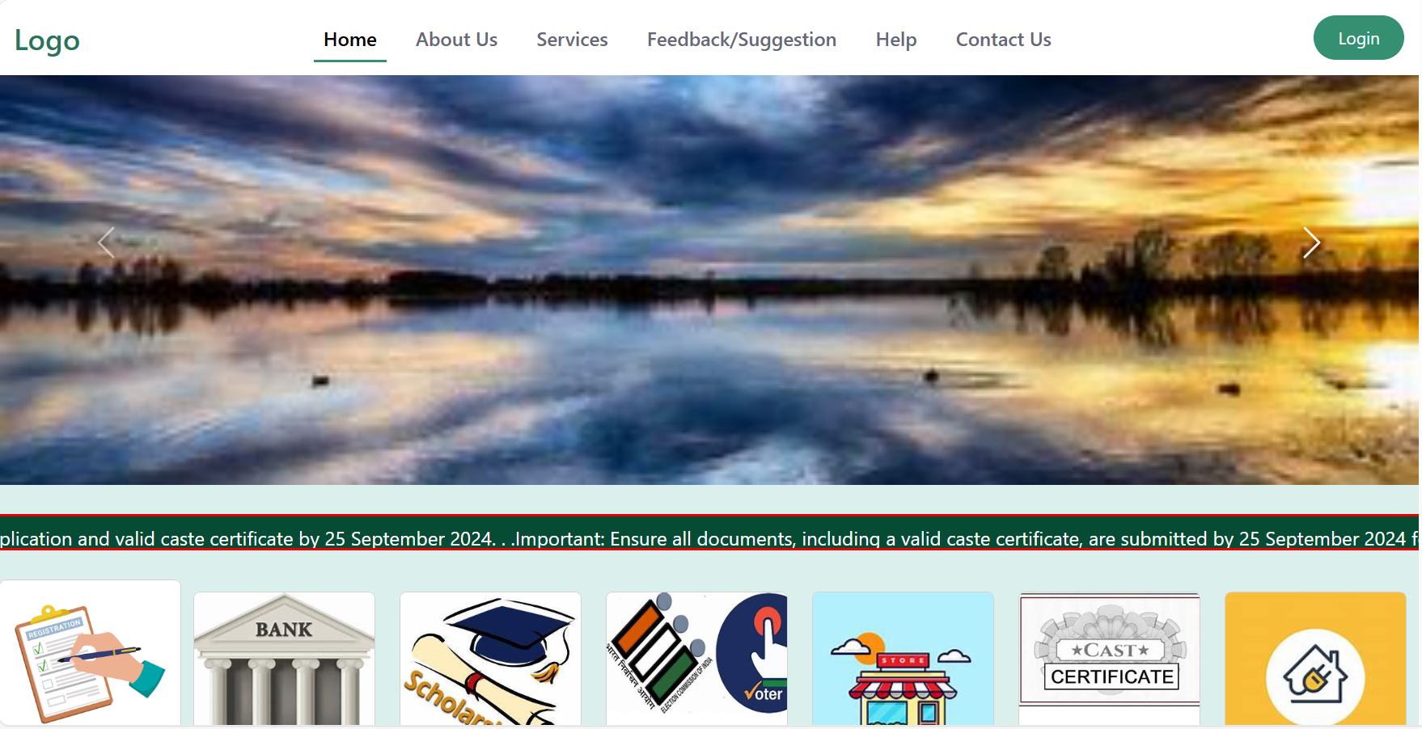  
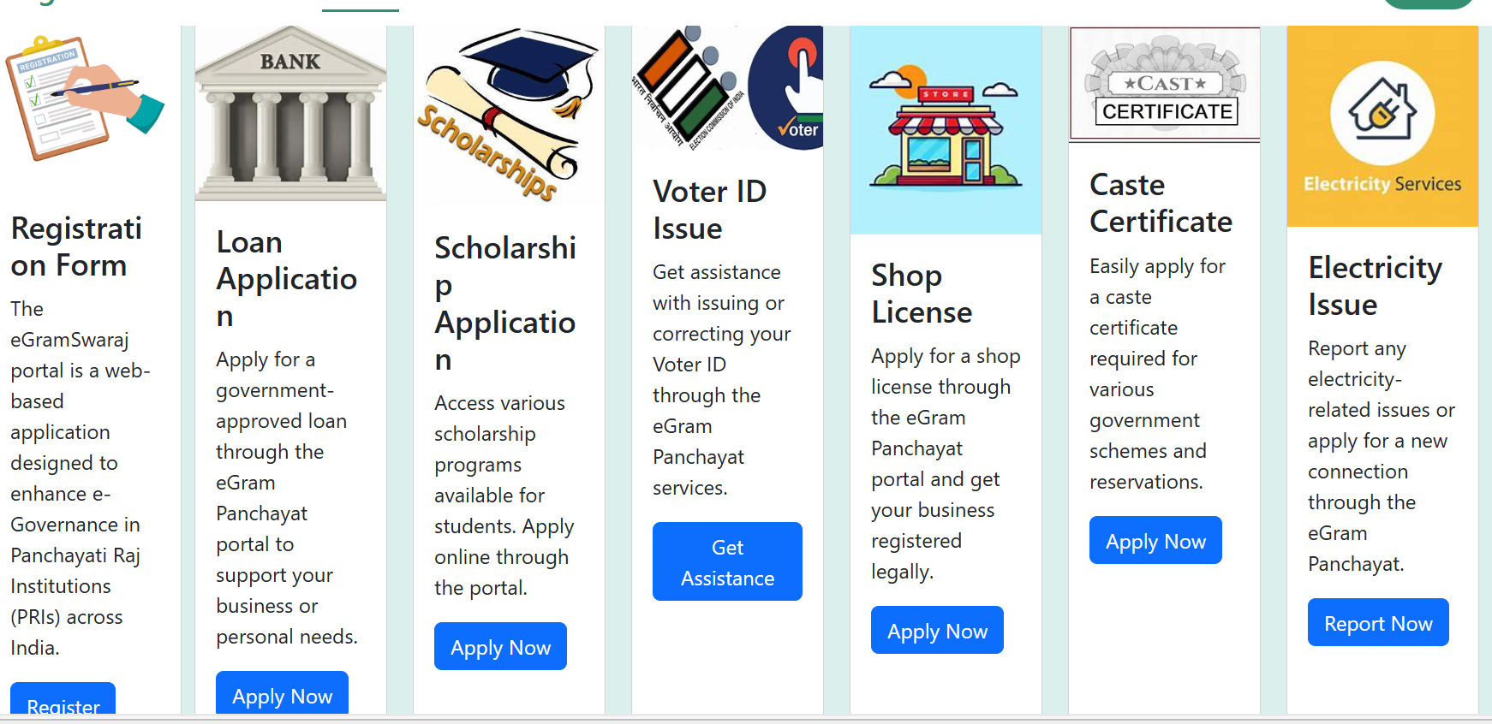

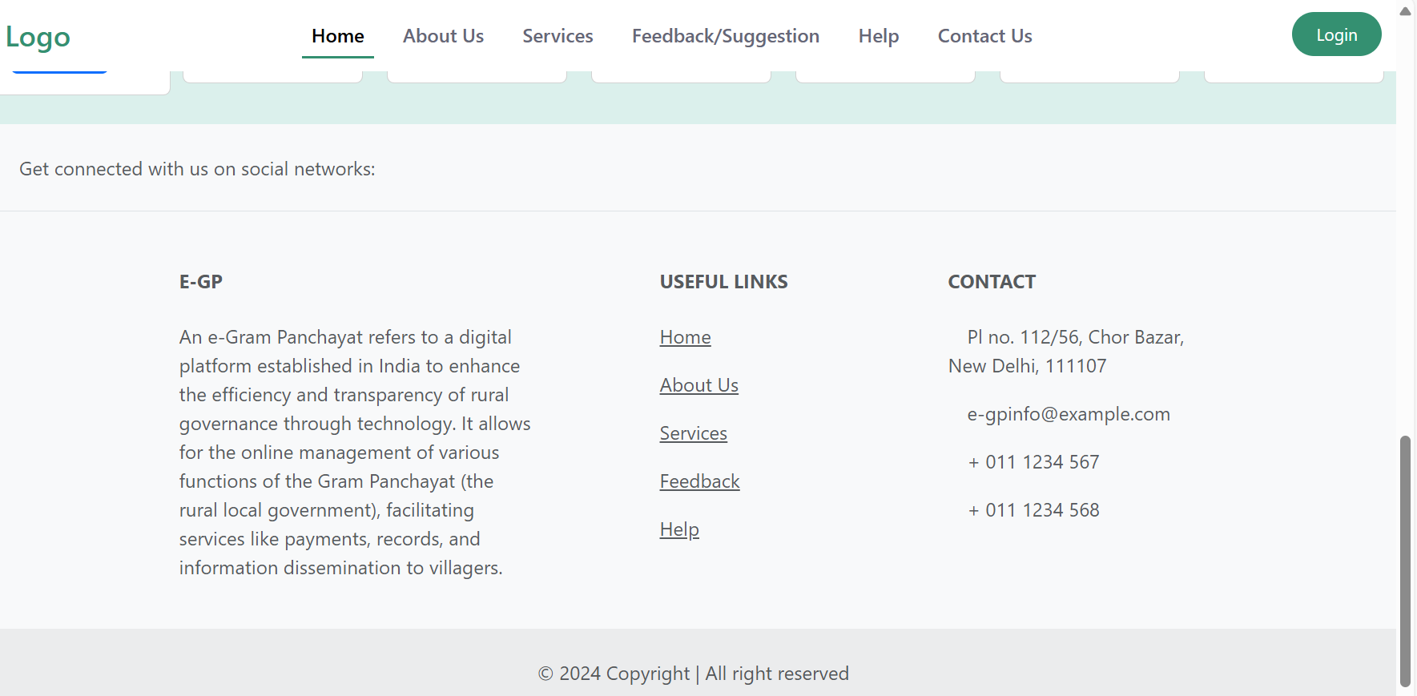  
  
2) NAVBAR



* Here firstly for every type of user there is a common webpage for home with a nav bar on top which includes our application logo which on click take us to the home page itself.
* There is home button which also take us to the home page

1. Then there is about us page which takes us to the page which shows all the details about the website and it looks like :-

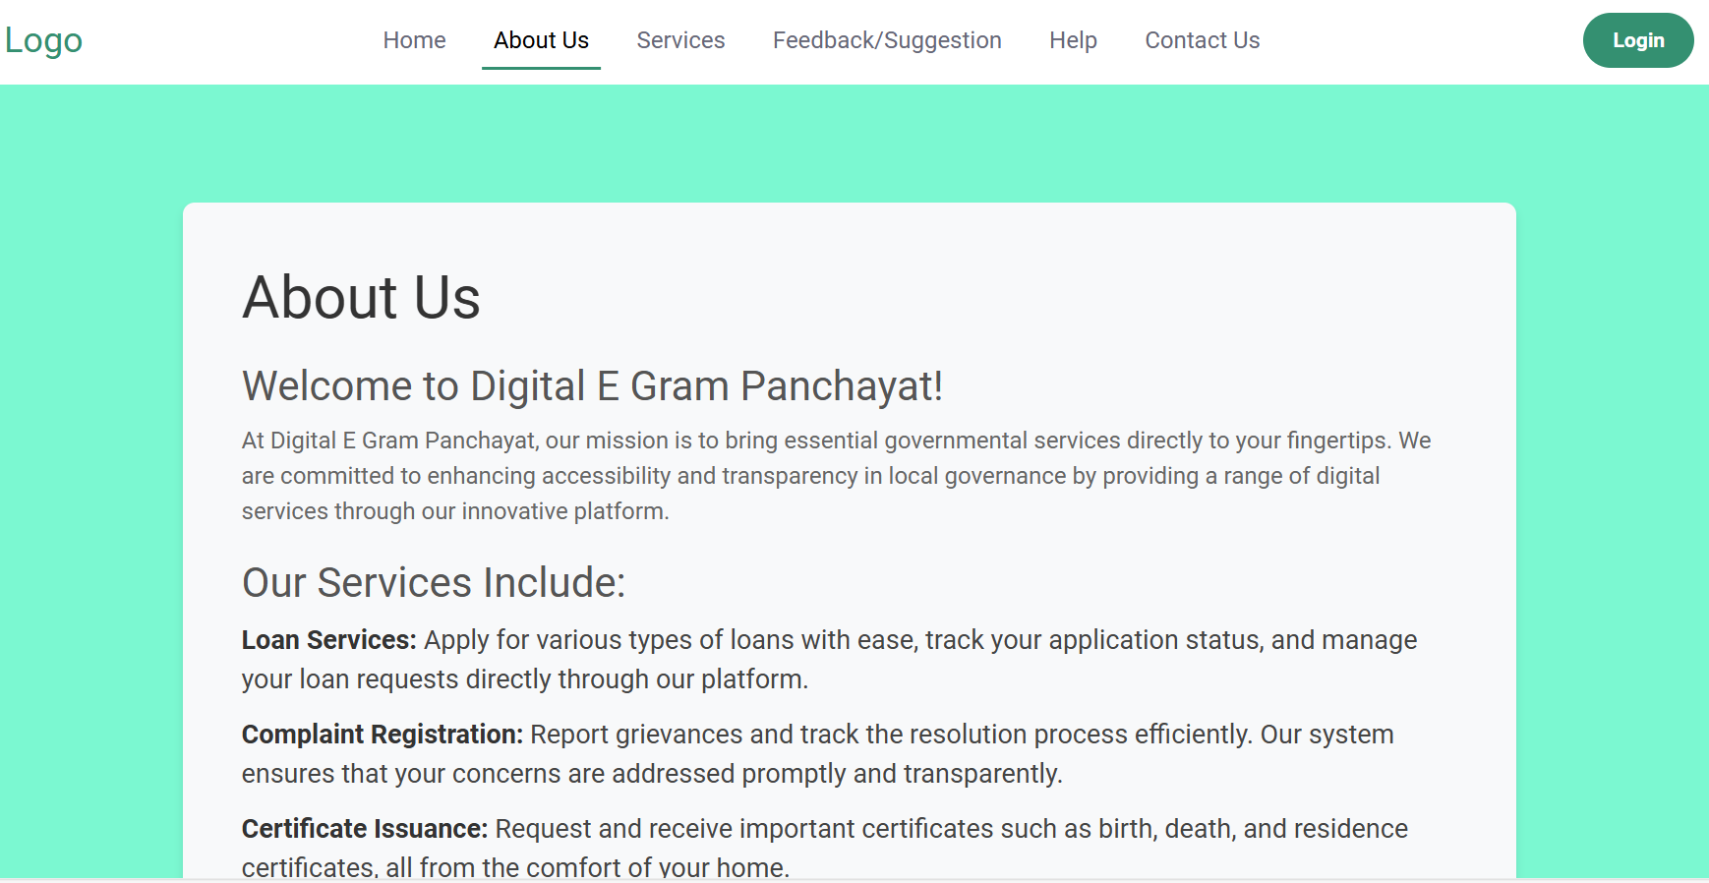

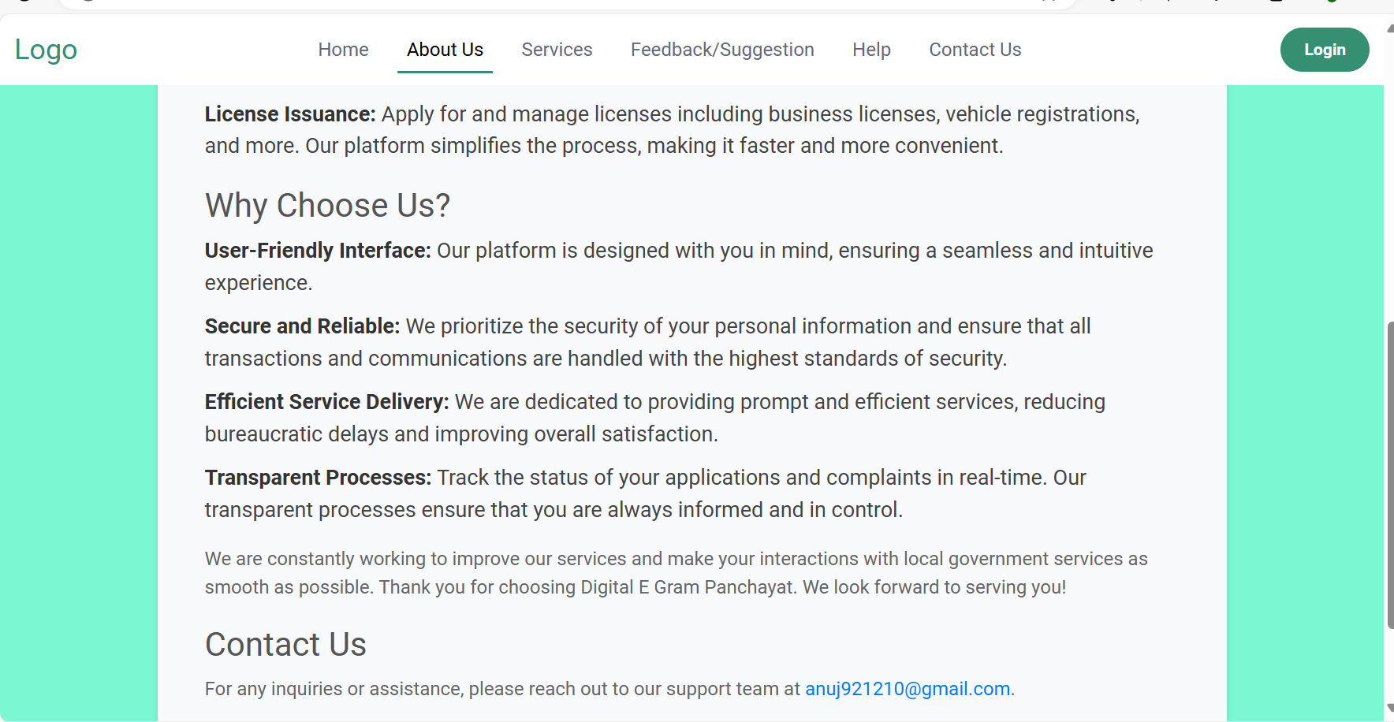

Then there is services option on navbar which is a dropdown and it is dynamic in nature means for user it shows the options to view services / apply for services and track applications options as shown below :-

//// Image user services dropdown

1. Then there is feedback/suggestion page from where user can send a complaint.

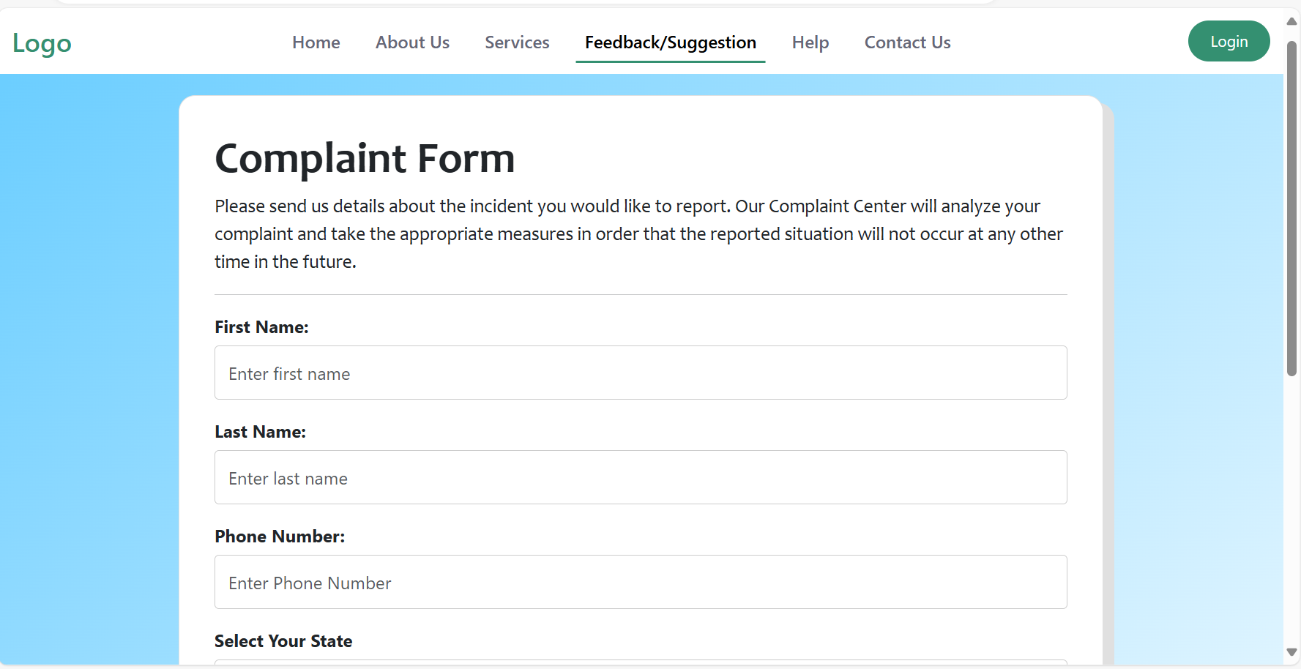

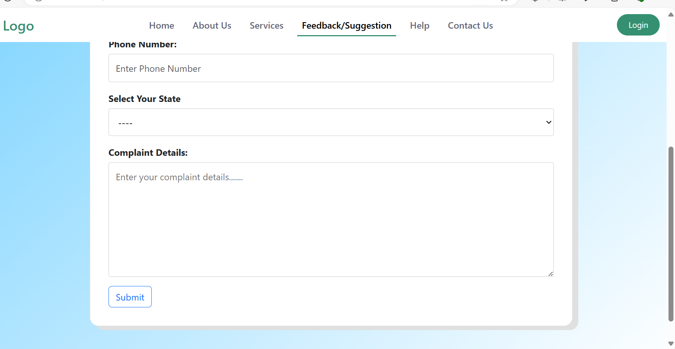

1. Then there is contact us page which shows all the related contact information at which user can contact us.

////// Create and add contact us page

1. At the end of navbar there is login option which will show login which means the user currently is not logged in and he should logged in first because without log in he will not be able to apply for the services. He can just view the services. He even can’t track the applications. Can’t view his profile
2. Login Page:-

* The login page is created common for all user , admin , and staff .
* The person can select accordingly as what he want to login as.
* There is also a create new user option which will take you to the registration form where you can only register as a new user because for security purpose staff and officer can only be registered from backend
* I have also given the user to sign in with google using Google OAuth.
* Once the user logged in the login option that was appearing there will be replaced by a dropdown in case of a user which will contain my profile option to view the user profile and logout option.
* Otherwise for the staff and the officer it will be changed to the logout option.

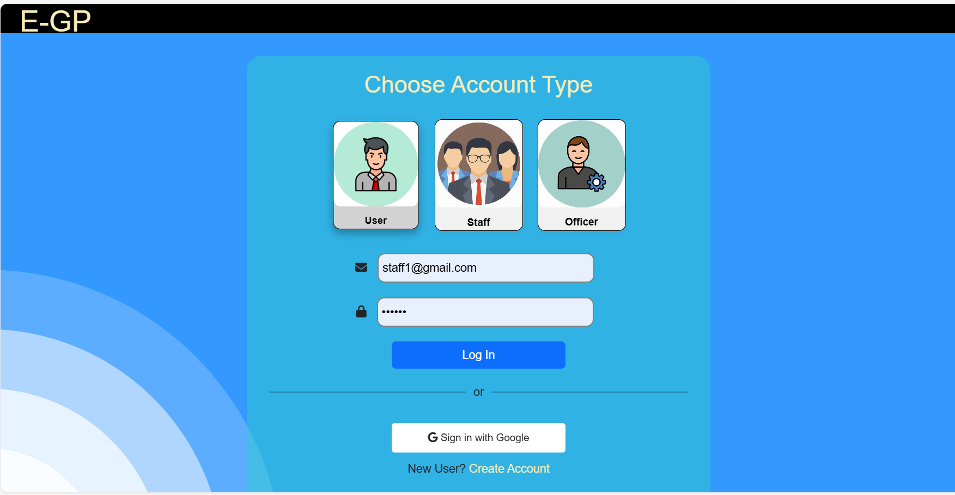

1. Register Page

* The register page looks like this:-
* 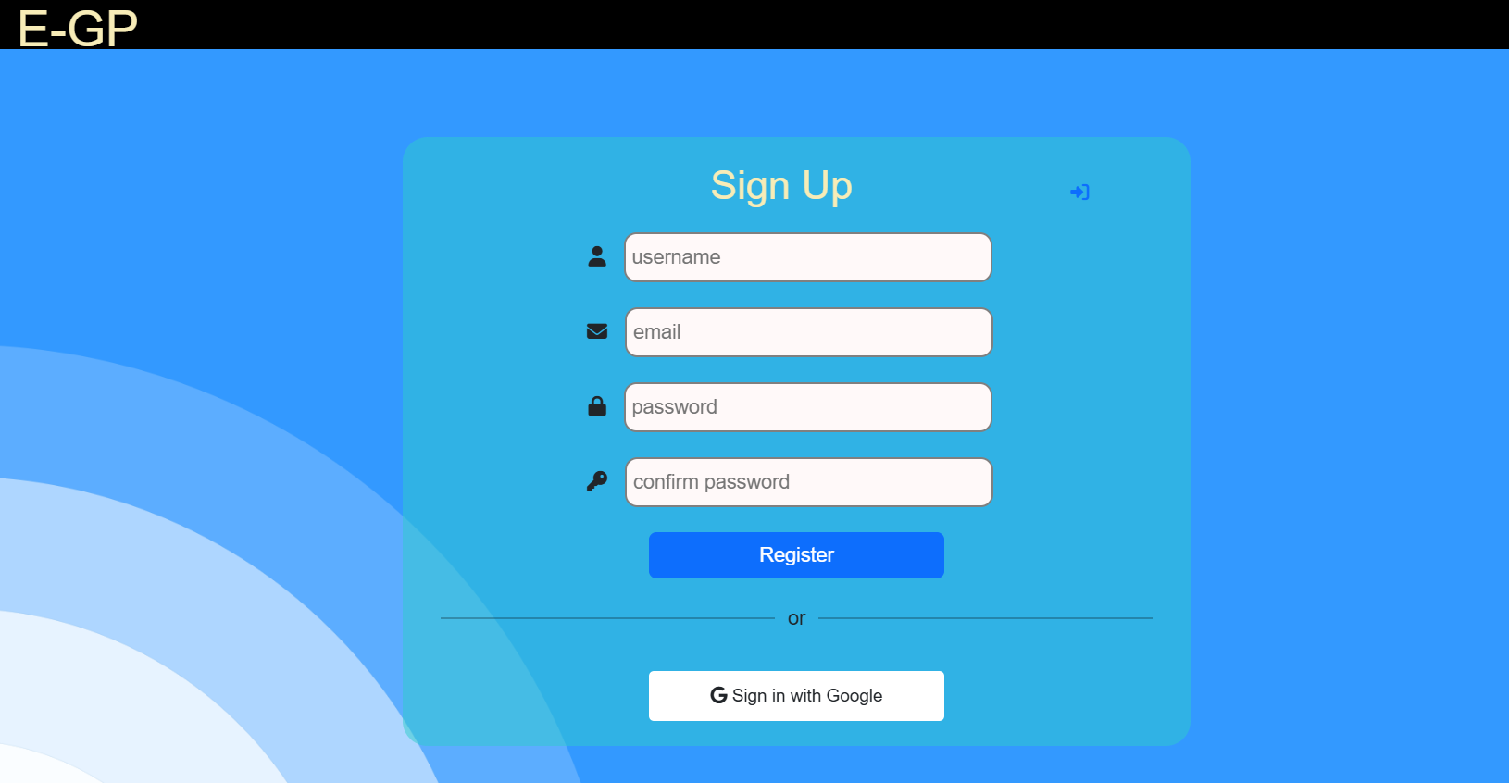On register page I have also given the option that if the user already exists than he can go to the login page directly from there .
* The register page have certain checks that the password should match the confirm password for securely register the user.

Once the user logged in either as staff/officer or user some of the website sections changes according to that providing flexibility accordingly.

SERVICE FUNCTIONALITY

When you logged in as a user:-

* You will have the privilege to view the different services page as shown below :-
* 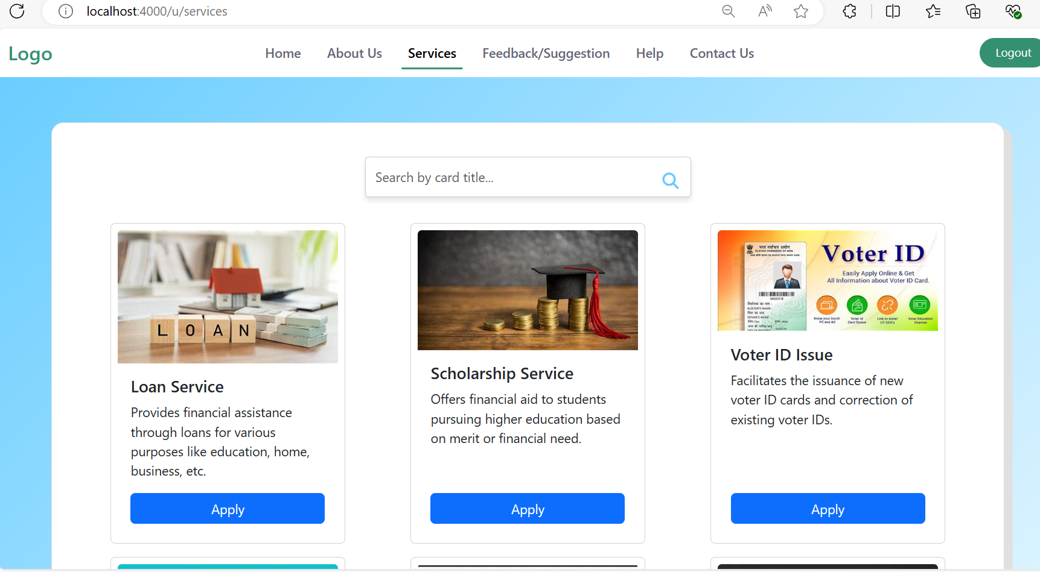

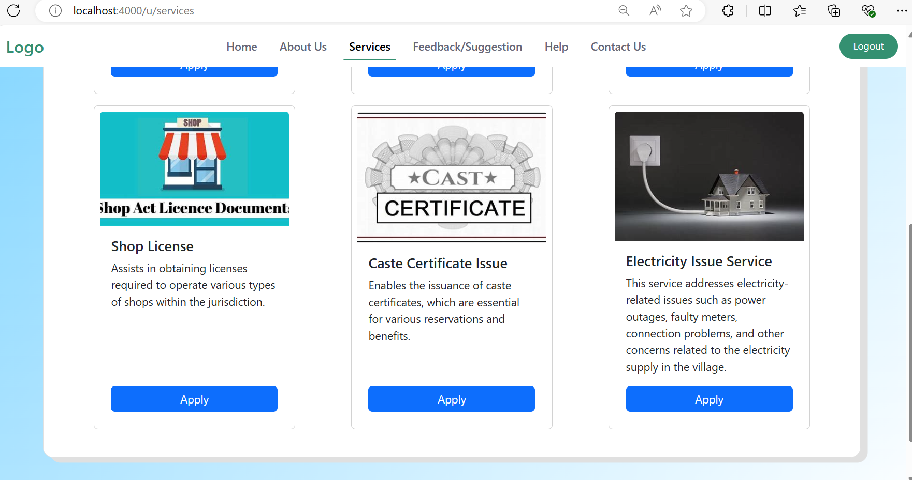

You will have the privilege to apply for the services. As shown above each of the services is having a apply button which will take you to the application form corresponding to that service from where you can apply for that service

1. Currently I have added 6 services which are loan service , electricity service , caste_certificate service , license service , voter_id service and scholarship service
2. Each service have their separate form according to the details that are required to fill for that service as shown below for each services :-
3. Loan services form

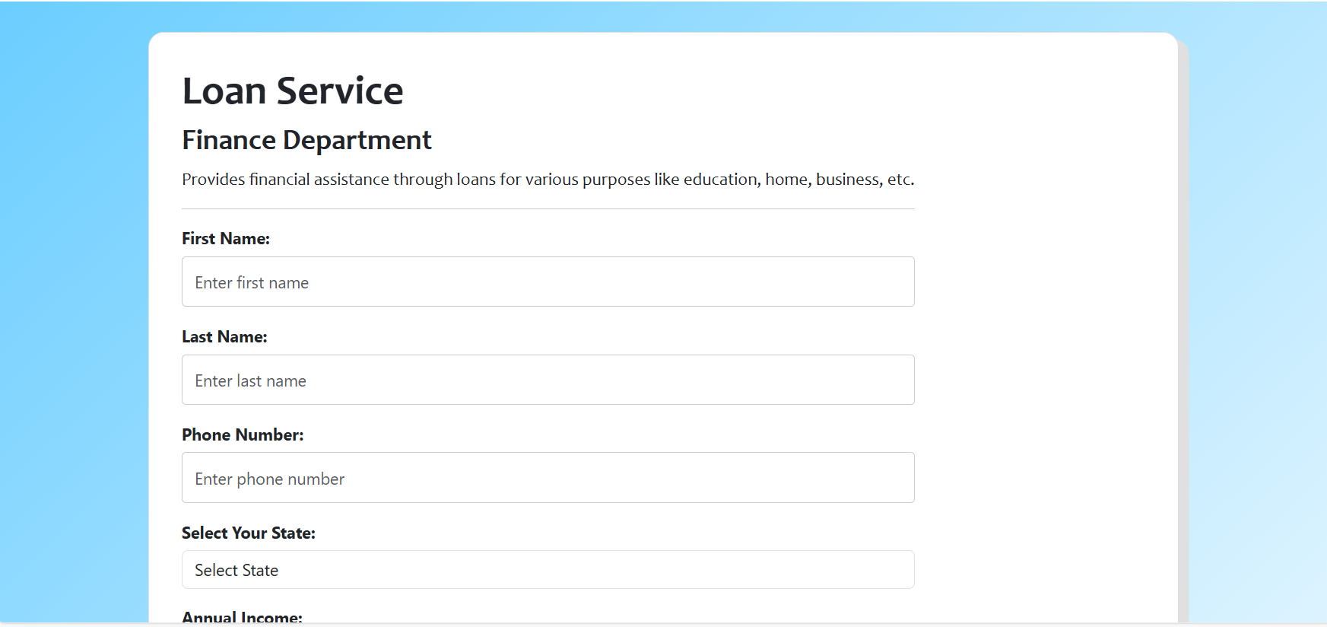

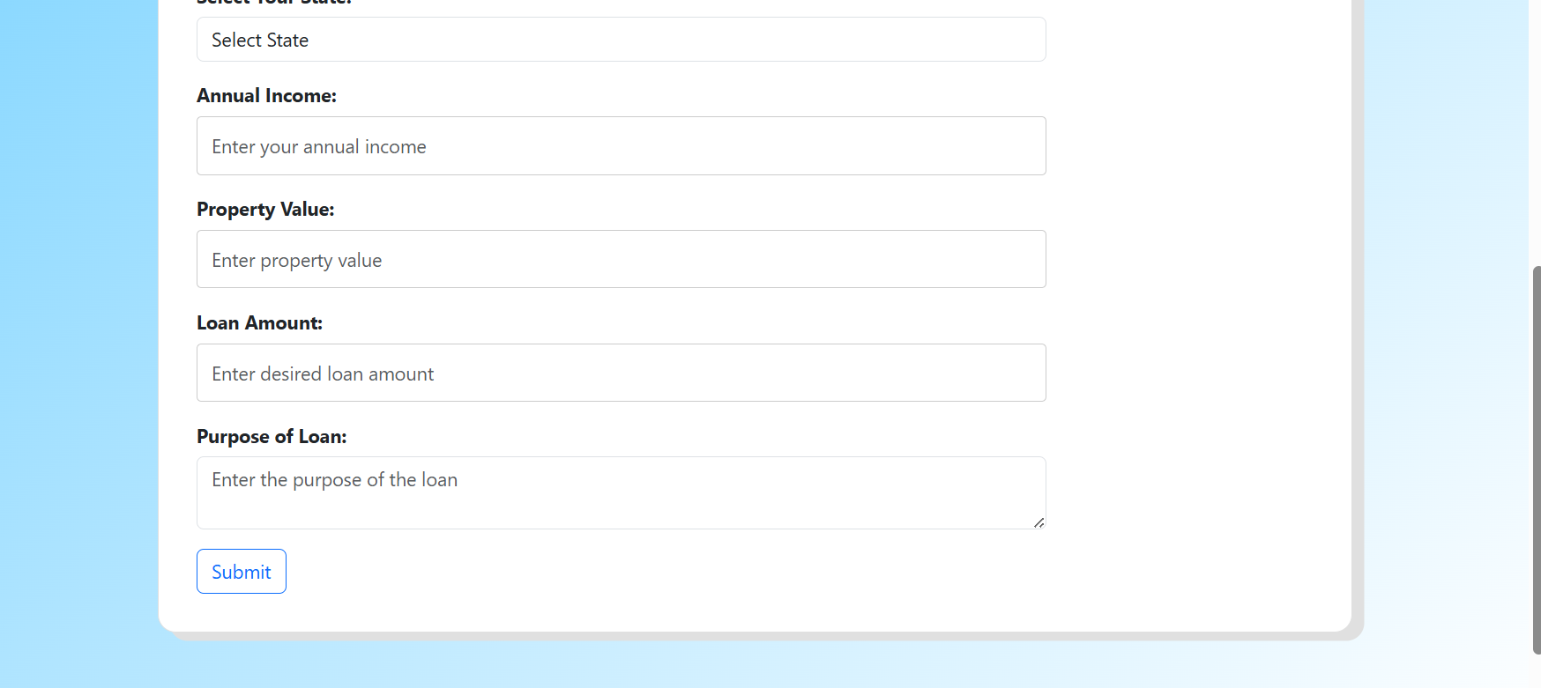

1. Electricity Service Form

//// Image of electricity  
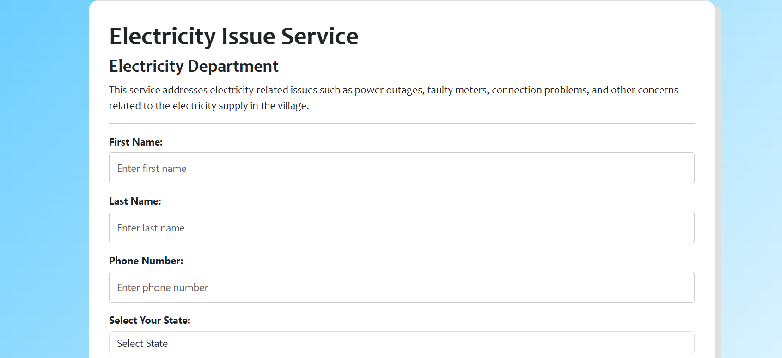  
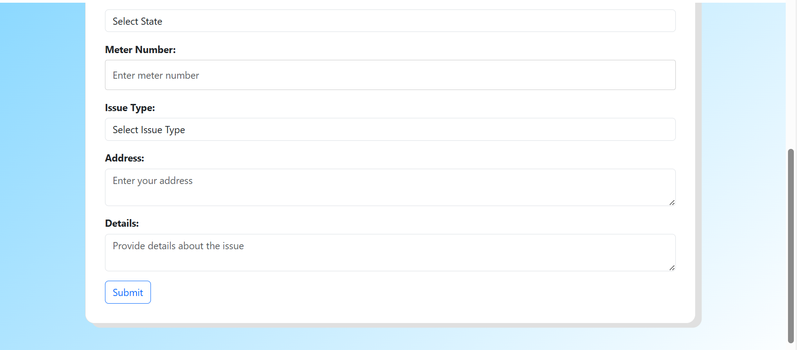

1. Caste_certificate service form  
   /// Image caste  
   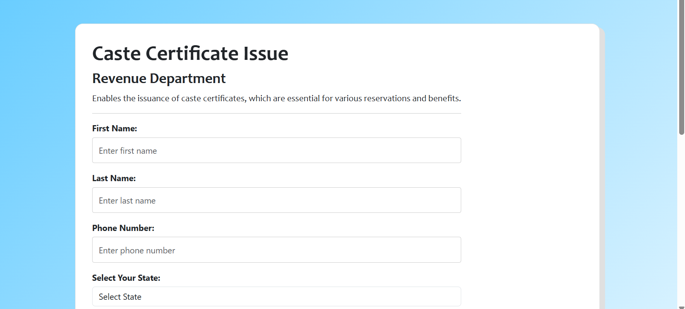  
   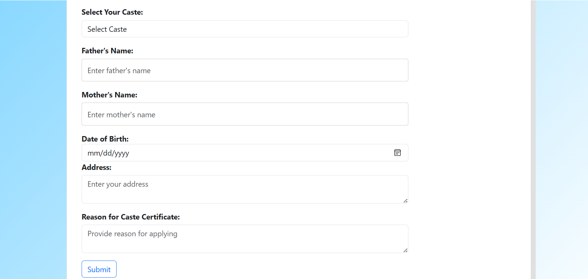
2. Scholarship services form  
   /// Scholarship  
   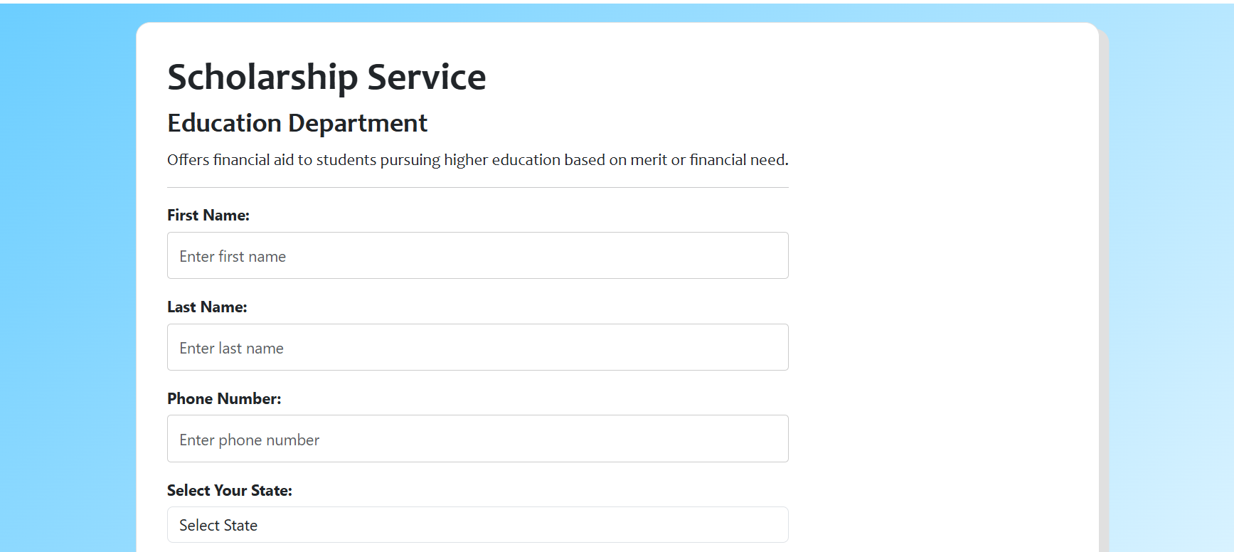  
   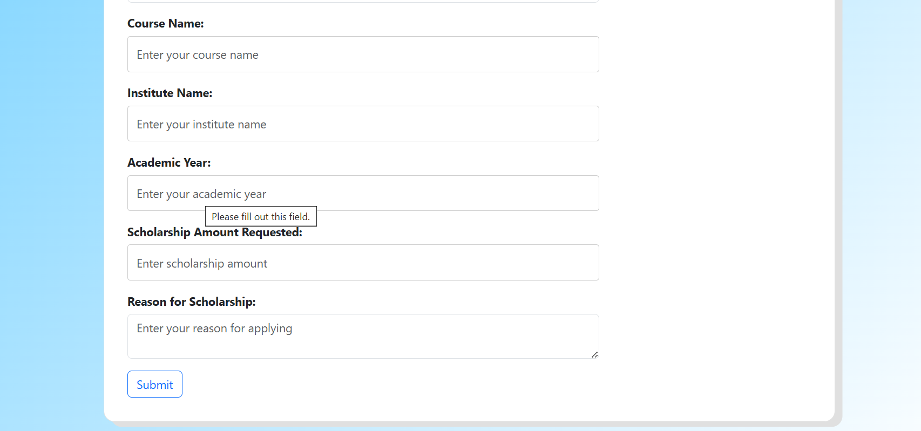
3. Voter_id service form   
   /// Voter id  
   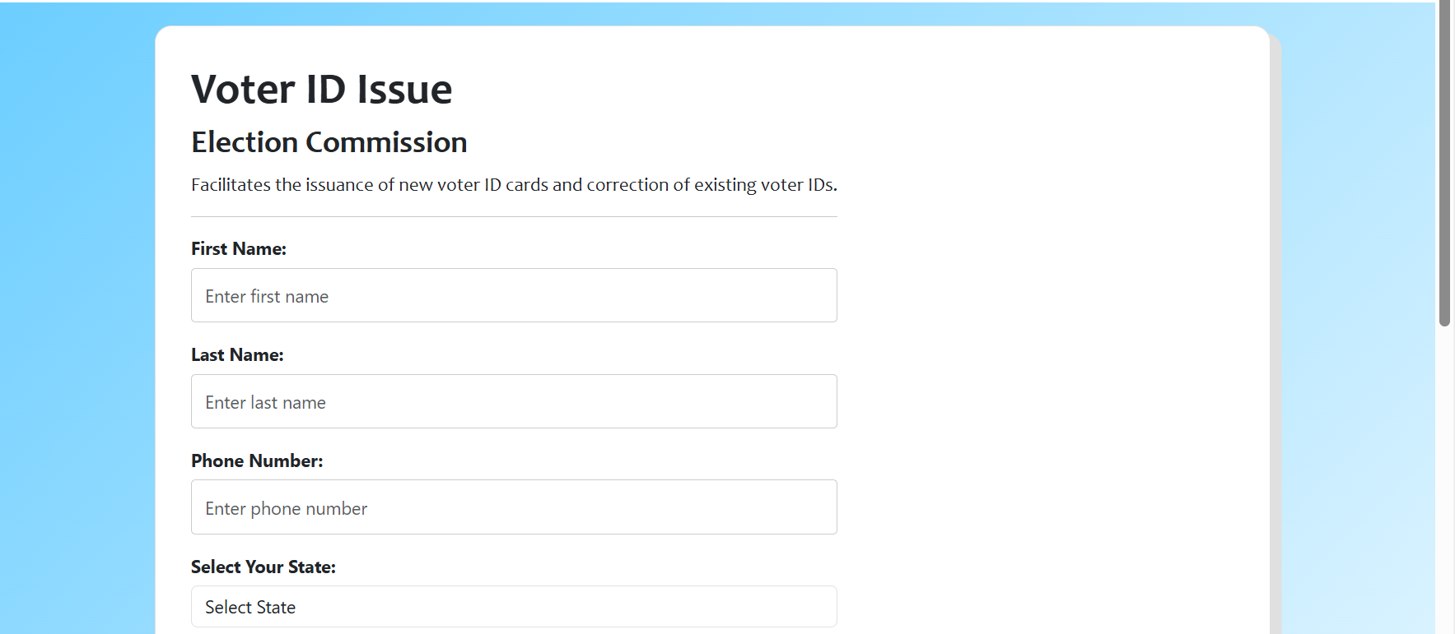  
   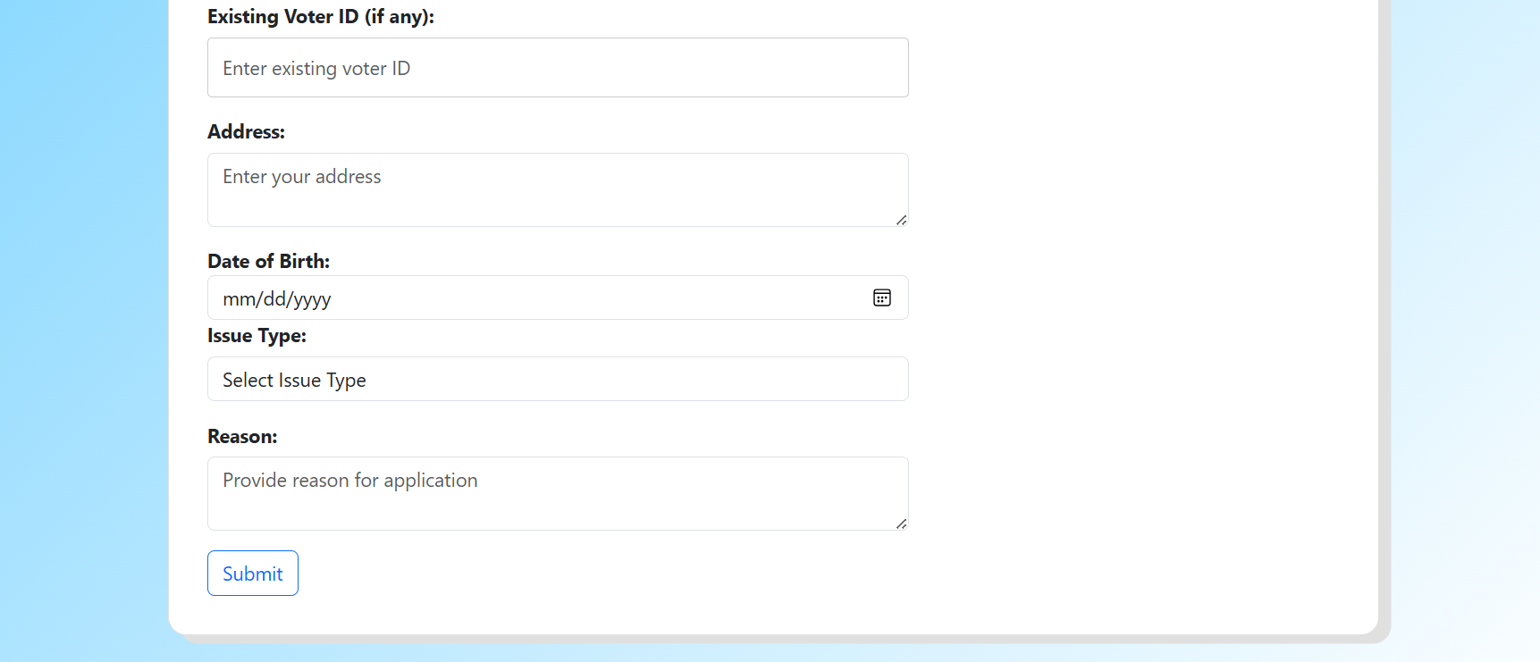
4. License service form  
   ///License  
   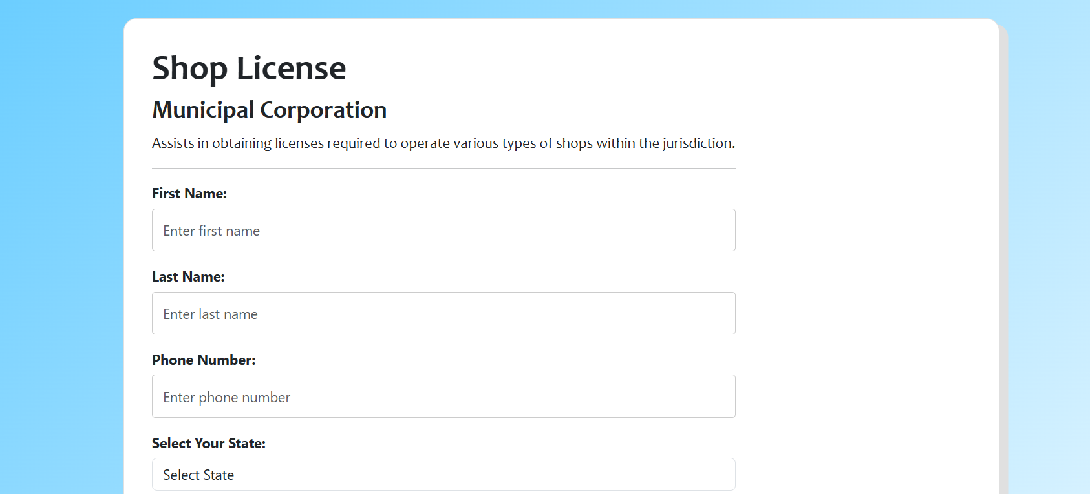  
   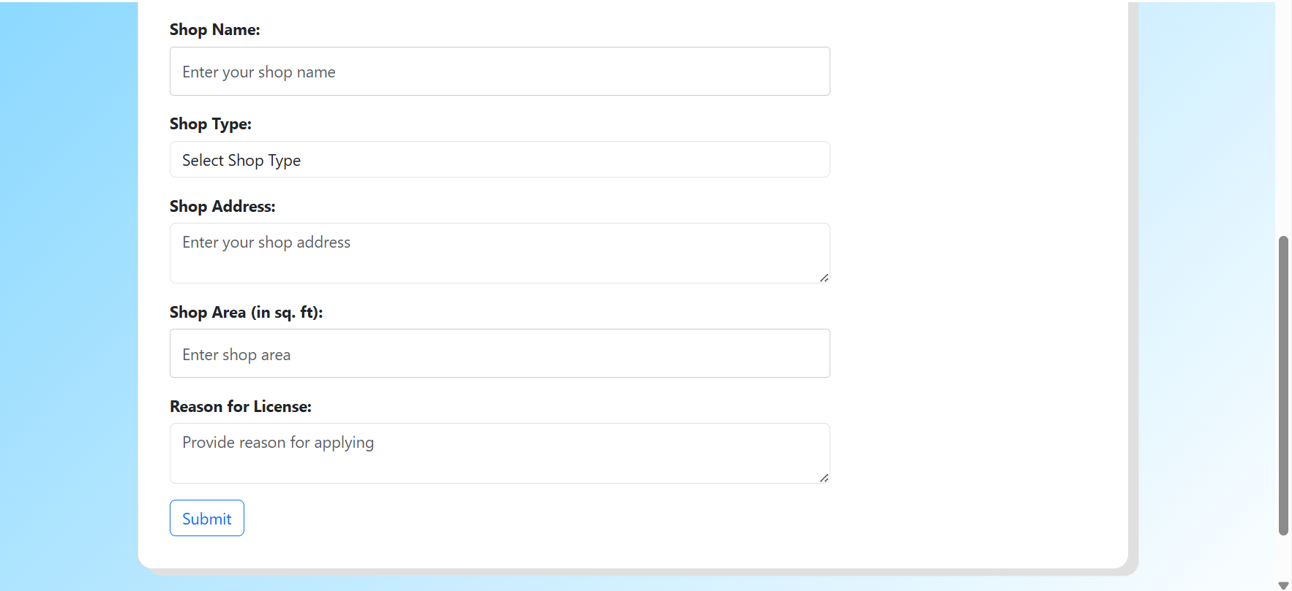

As the forms are filled a unique application id is generated corresponding to that form and saved the application details to the databse.

Each service I provide have a separate database to corresponding to them

There is also a table which contains the details of the user_service about the application no applied and the status of that application

Now the staff service page :-  
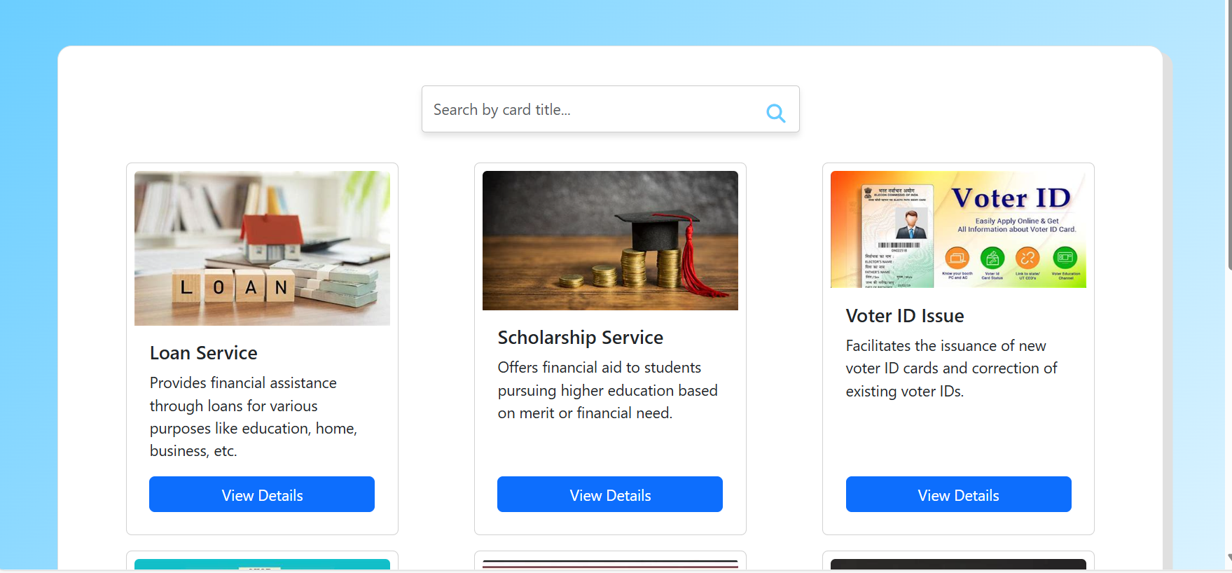  
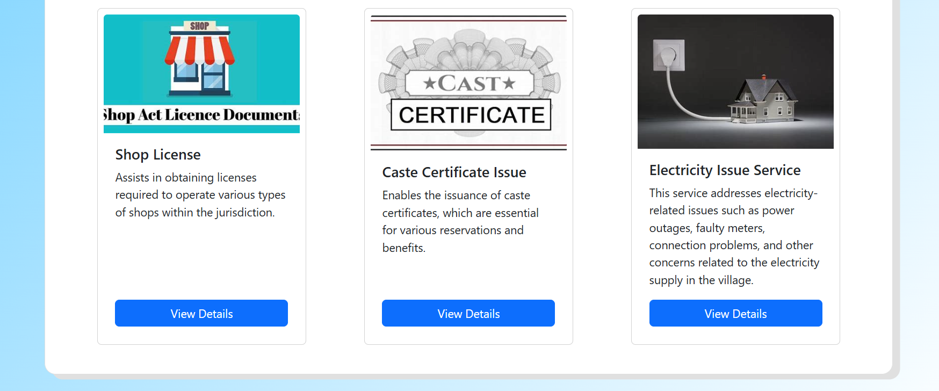

1 ) The staff can see all the details of the service

A ) There is a services page for staff which will show all the details of the services as in case of user but here with the view details button.

The view details button will navigate you to a page where it will show you all the details of that service

As shown in images :-

1. Scholarship  
   /// Image  
   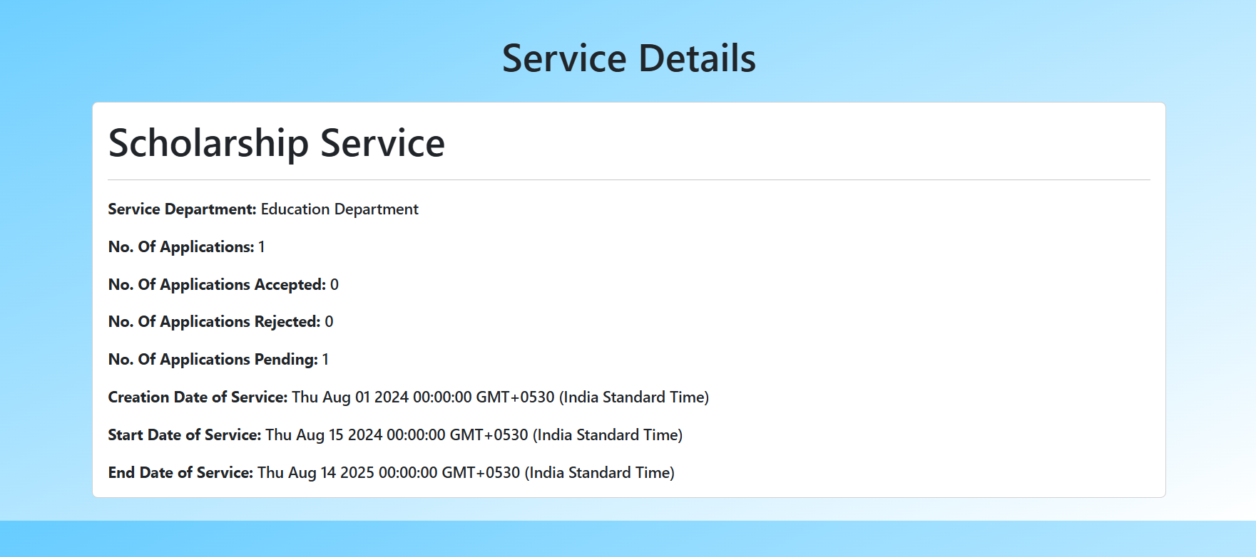
2. Loan   
   /// Image  
   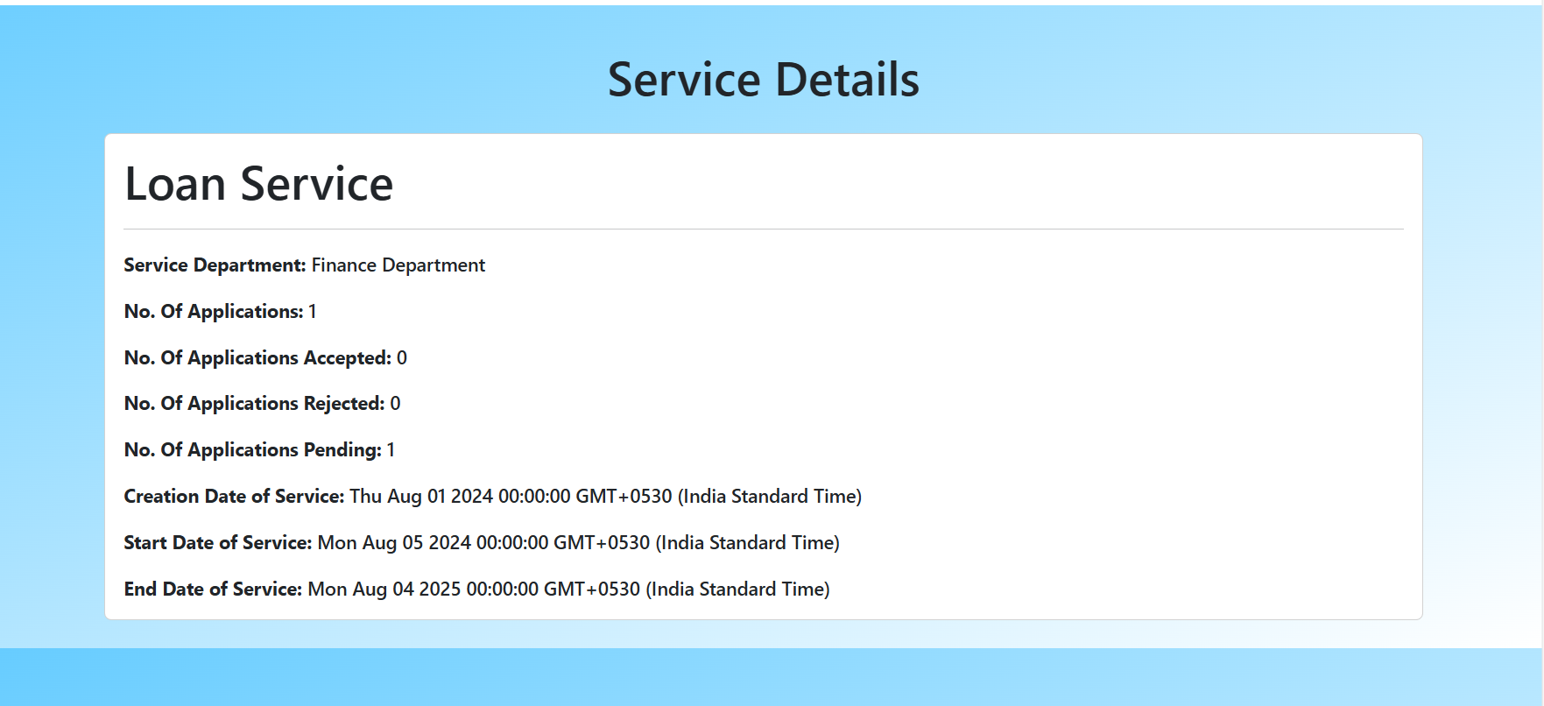
3. Electricity  
   /// Image  
   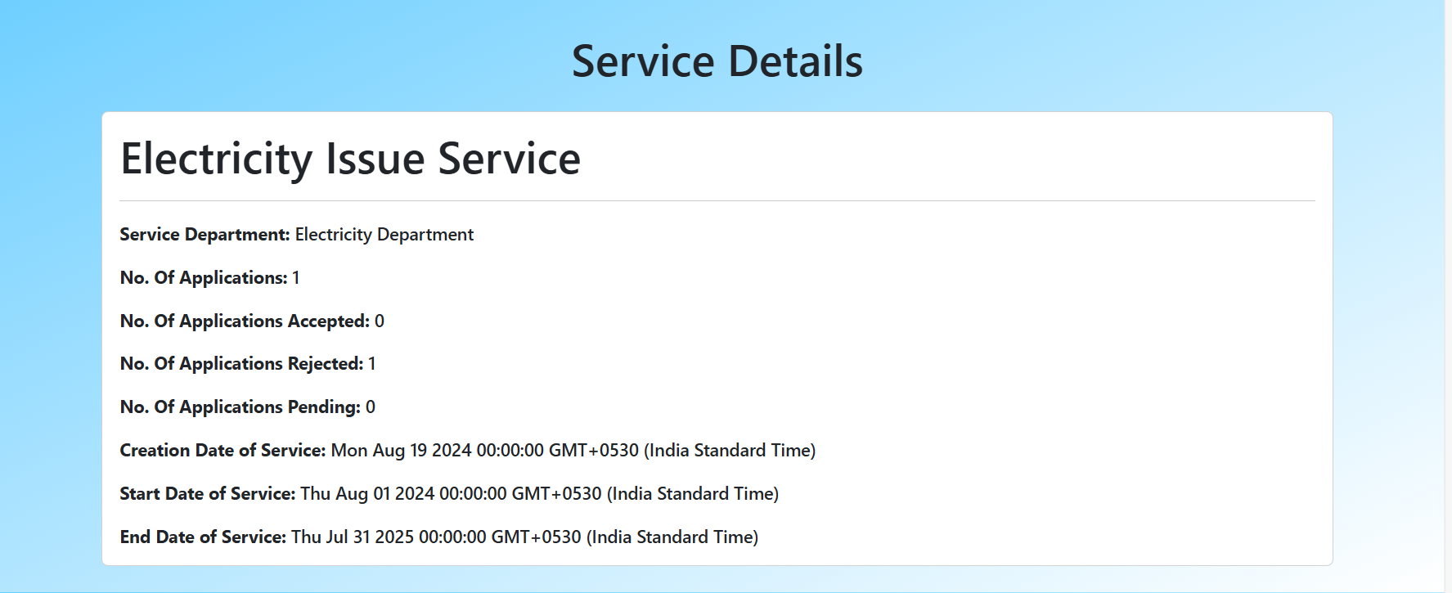
4. License  
   /// Image  
   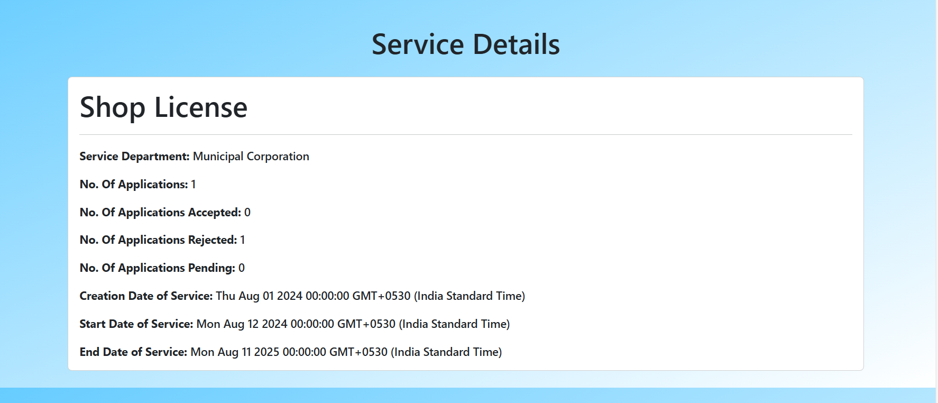
5. Voter ID  
   /// Image  
   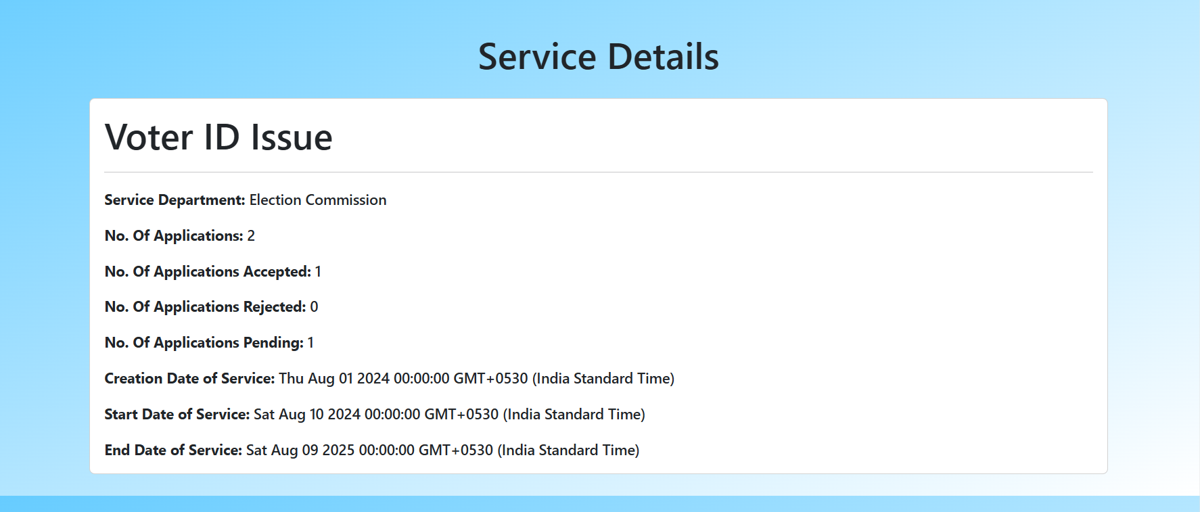
6. Caste Certificate   
   /// Image  
   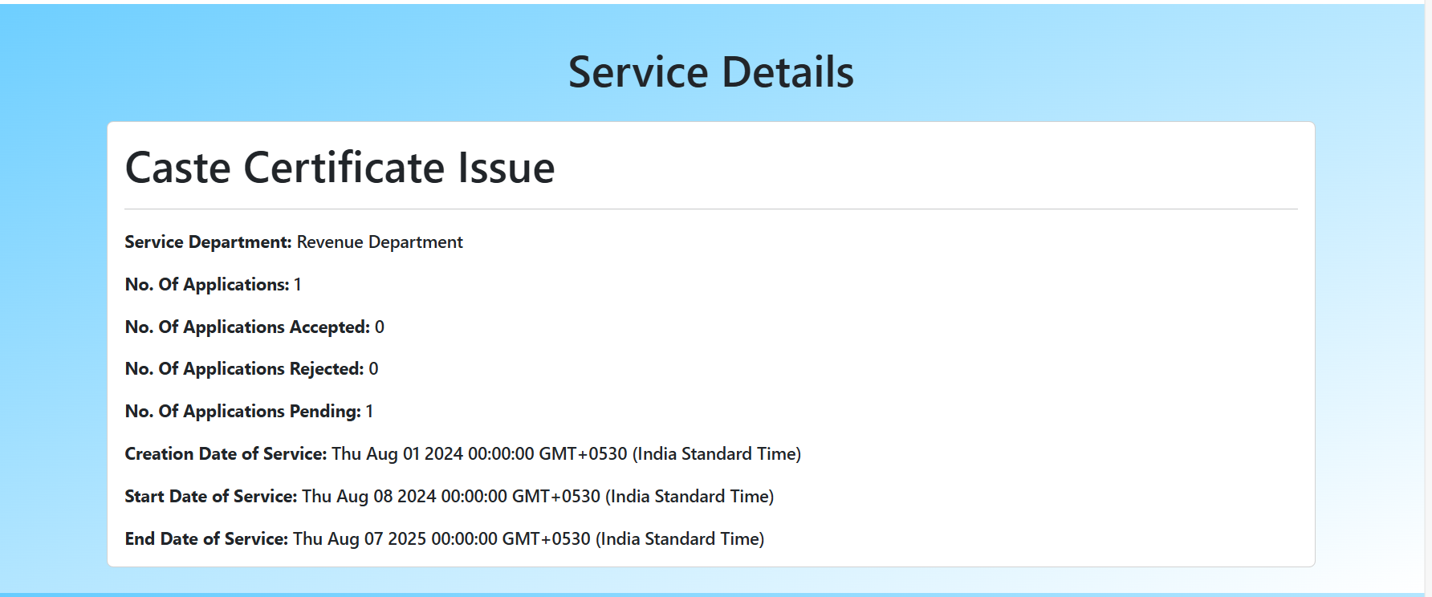

Here the staff member or the officer can update the application status of the appliactions  
One he updates the application status to approved or rejected the status will show in user track my application status and that application will now shown to the staff/officer now.  
As they will only shown the application with status as pending.

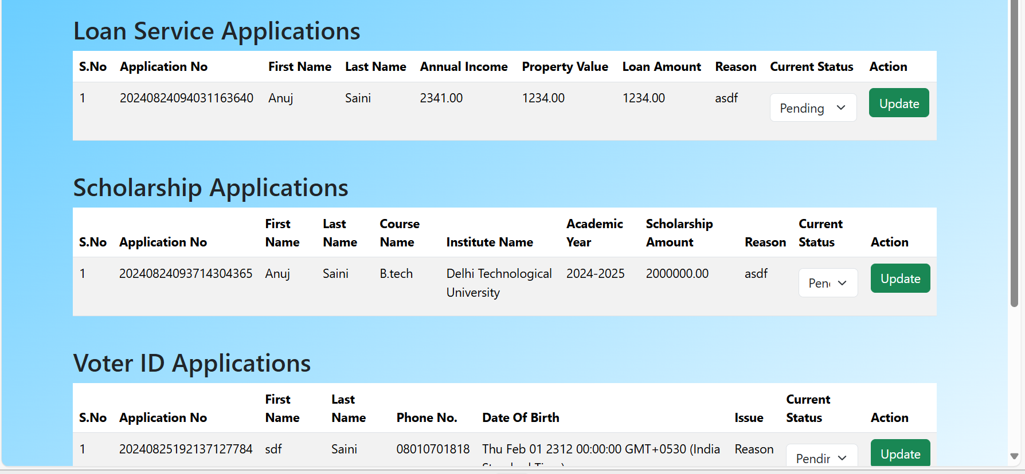

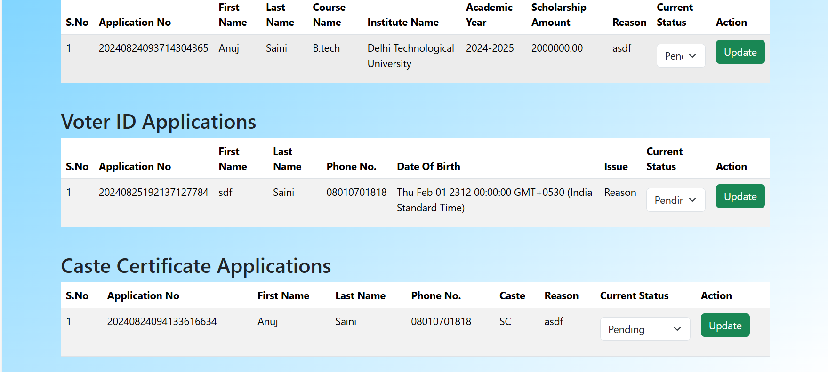

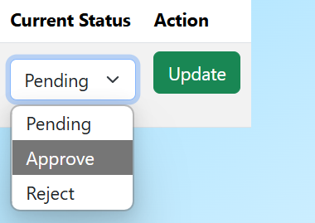

Database Tables :-  
User_service table   
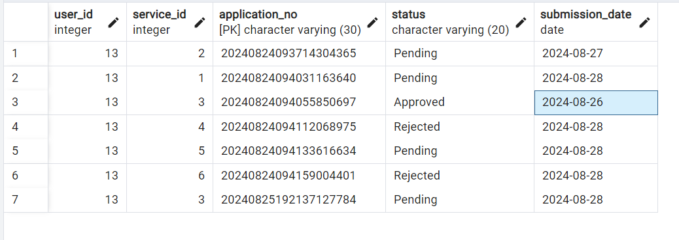

Account_details table   
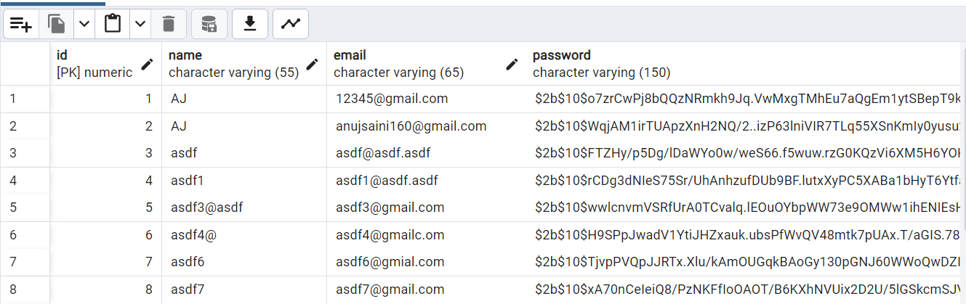

Services_details table :-

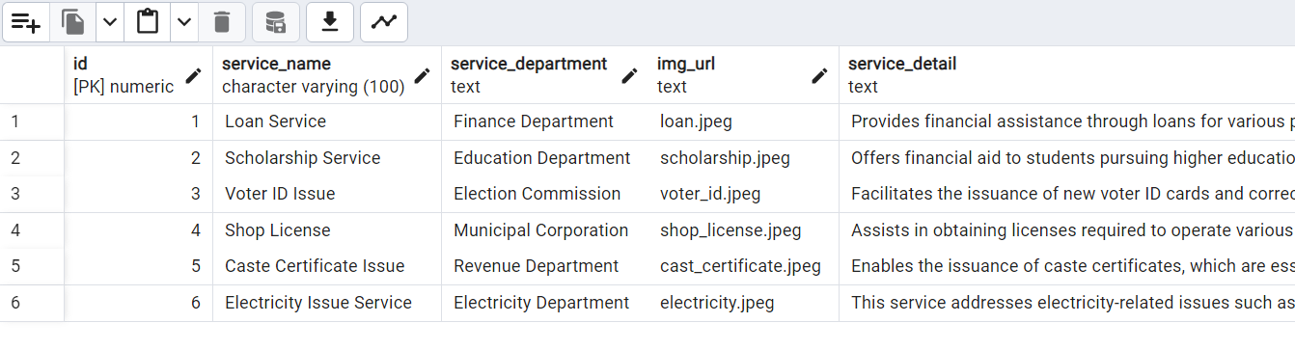

Caste certificate table :-



Electricity table :-

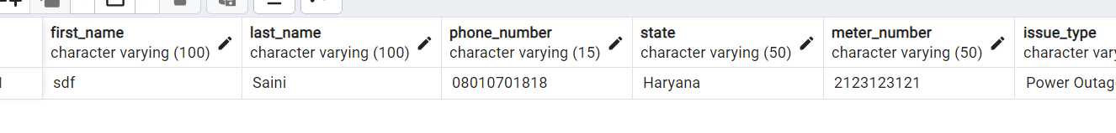

License table :-



Loan table :-



Scholarship table :-



Voter id table :-

